 | Mental Recall | Maths  Oak Academy   | English  Oak Academy | Wider Curriculum  Oak Academy | Study Ladder  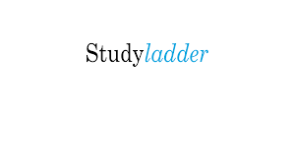 | Spellings  Reading  Projects
Mon | Mathletics  TT Rockstars  Weekly Mental Maths | Finding 10, 100 or 1,000 more than a number | Past and present tense | Science | Editing Text - Spelling | See home learning books for projects and spellings.
Tues |  | Rounding numbers to the nearest 10 | Past and present tense | Science | Word building
Wed |  | Rounding numbers to the nearest 100 | Exploring word class | PSHE | I don't want to get up today - poetry
Thurs |  | Rounding numbers to the nearest 1000 | Past and present tense | PSHE | Deserts comprehension
Fri |  | Finding the odd one out | Past and present tense | RE | Synonyms

